login -> issues screen- >customers -> locations
status, service issue, pure program ?, oil pickup status, oil service type, trap service status, id, name, address, city, state
(click on name of company opens profile page) ->
profile page -> 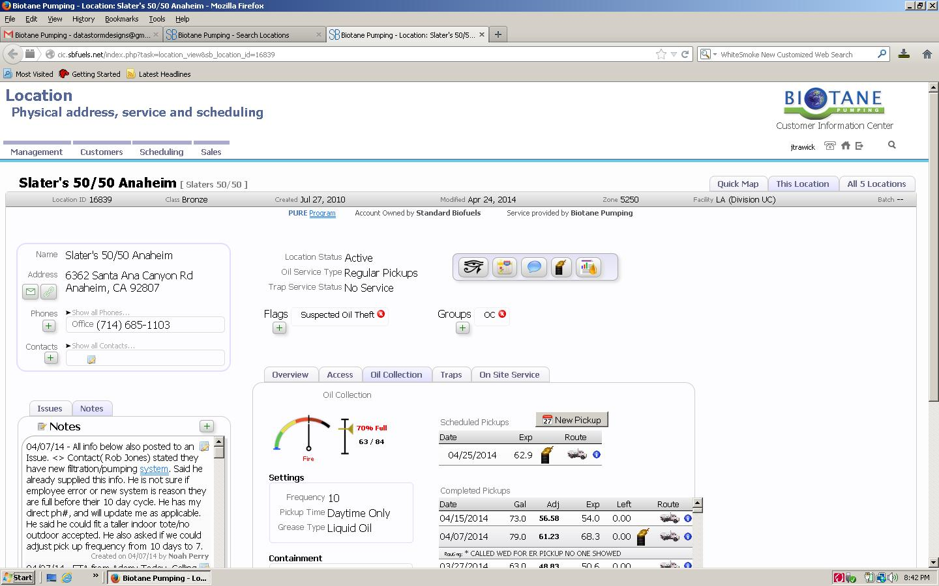
butttons :
edit: email/ web link / phone / contacts
issues(date – message ) / notes
overview /
access / ( graph is estimate on how much it should be filled daily )
key number ?
access codes ?
map number
lattitude
longitude
oil collection /
scheduled pickups -> new pickups button
frequency (integer)
pickup time ( anytime/daytime/nightime/business hours)
grease type ( liquid oil/hard grease/cubes)
containtment
class ( barrel / stock id)
additional containtment
gallons/
traps /
on site service

pick up logs

Management - >
Reports
New Locations
Oil Pickup Summary
Oil collection
Account cancellations
Account Expirations
Pickup Frequency
Zero-Gallon Pickups
Oil Theft
Container Deliveries
Colleted Fires
Customer Support Activity

Staff ->
New staff (add staff) ->
Staff roles
Customer report
Account representative
Sales representative
Sales Leads User
Service Driver
Oil Driver
Scheduler
Facility
Corporate Manager
Shop crew
Sales Zone Manager
Can Be Assigned Issues
MMS for New fires
MMS for Call Center Message
MMS for Theft Alert
Receive Phone Messages

